**SOURCE CODE:**

#include<stdio.h>

int main(void){

int arr[3][3],d,i,n,j,k,flag;

printf("Enter the value of n: ");

scanf("%d",&n);

//Insertion

for(i=0;i<n;i++){

for( j=0;j<n;j++){

printf("Enter element %d%d: ",i+1,j+1);

scanf("%d",&arr[i][j]);

}

}

for( i=0;i<n;i++){

for(j=0;j<n;j++){

printf("%d ",arr[i][j]);

if(j==n-1)

printf("\n");

}

}

printf("Press 1 to delete the main diagonal elements... ");

scanf("%d",&d);

//Deletion

if(d==1){

for( i=0;i<n;i++){

for( j=0;j<n;j++){

if(i==j){

for( k=j;k<n-1;k++){

arr[i][k]=arr[i][k+1];

}

arr[i][k]='\0';

}

}

}

printf("After deletion...\n\n");

for( i=0;i<n;i++){

for(j=0;j<n-1;j++){

printf("%d ",arr[i][j]);

}

printf("\n");

}

}

//search

int num;flag=0;

printf("Enter the number to be searched: ");

scanf("%d",&num);

for(i=0;i<n;i++){

for(j=0;j<n-1;j++){

if(arr[i][j]==num){

flag=1;

break;

}

}}

if(flag==1)

printf("Element found!!\n");

else

printf("Element not found!!\n");

return 0;

}

**OUTPUT:**

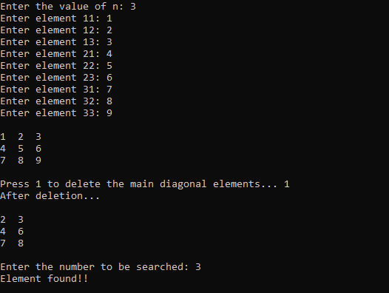

**RESULT:**

**The matrix is created and necessary Operations(Insert,deleting diagonal elements,Search) are executed Successfully.**

**SOURCE CODE:**

#include<stdio.h>

int main(void){

int a[10][10],b[10][10],c[10][10],i,j,n;

printf("Enter the value of n: ");

scanf("%d",&n);

printf("Enter matrix A:\n");

//getting input

for( i=0;i<n;i++){

for( j=0;j<n;j++){

printf("a%d%d: ",i+1,j+1);

scanf("%d",&a[i][j]);

}

}

printf("Enter matrix B:\n");

for( i=0;i<n;i++){

for( j=0;j<n;j++){

printf("b%d%d: ",i+1,j+1);

scanf("%d",&b[i][j]);

}

}

//adding

for( i=0;i<n;i++){

for( j=0;j<n;j++){

c[i][j]=a[i][j]+b[i][j];

}

}

//printing

printf("Matrix Addition is:\n");

for( i=0;i<n;i++){

for( j=0;j<n;j++){

printf("%d ",c[i][j]);

if(j==n-1)

printf("\n");

}

}

return 0;

}

**OUTPUT:**

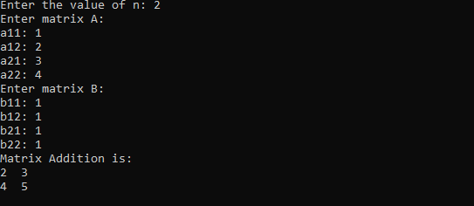

**RESULT:**

**The matrix addition Operation is executed Successfully using Multi-dimensional Array.**

**SOURCE CODE:**

#include <stdio.h>

int main(){

int i, j, k, arr1[15][15], arr2[15][15], arr3[15][15], n, sum=0;

printf("Enter the value n:");

scanf("%d", &n);

printf("Enter array 1:\n");

//getting input

for(i=0; i<n; i++){

for(j=0; j<n; j++){

printf("Enter arr1[%d][%d]:", i+1, j+1);

scanf("%d", &arr1[i][j]);

}

}

printf("Enter array 2:\n");

for(i=0; i<n; i++){

for(j=0; j<n; j++){

printf("Enter arr2[%d][%d]:", i+1, j+1);

scanf("%d", &arr2[i][j]);

}

}

//calculating multiplication and printing

for(i=0; i<n; i++){

for(j=0; j<n; j++){

for(k=0; k<n; k++){

sum += ( arr1[i][j] * arr2[j][i] );

}

arr3[i][j] = sum;

sum=0;

printf("%d ", arr3[i][j]);

}

printf("\n");

}

return 0;

}

**OUTPUT:**

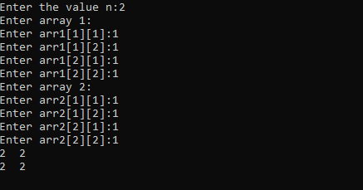

**RESULT:**

**The matrix Multiplication Operation is executed Successfully using Multi-dimensional Array.**

**SOURCE CODE:**

#include<stdio.h>

int main(void){

int a[3][3],b[3][3],i,j;

//getting

for( i=0;i<3;i++){

for( j=0;j<3;j++){

printf("Enter a%d%d: ",i+1,j+1);

scanf("%d",&a[i][j]);

}

}

printf("The given matrix is:\n");

//printing given matrix

for( i=0;i<3;i++){

for( j=0;j<3;j++){

printf("%d ",a[i][j]);

if(j==2)

printf("\n");

}

}

//processing transpose of given matrix

for(i=0;i<3;i++){

for(j=0;j<3;j++){

b[i][j]=a[j][i];

}

}

//printing transpose of given matrix

printf("Transpose of the given matrix is:\n");

for( i=0;i<3;i++){

for( j=0;j<3;j++){

printf("%d ",b[i][j]);

if(j==2)

printf("\n");

}

}

return 0;

}

**OUTPUT:**

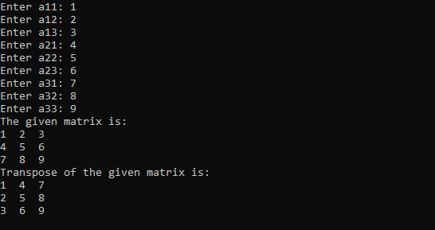

**RESULT:**

**The matrix Transpose Operation is executed Successfully using Multi-dimensional Array.**

**SOURCE CODE:**

#include<stdio.h>

int main(void){

long int arr[6][6],i,j,n;float avg;

printf("Enter the no of students: ");

scanf("%d",&n);

//getting input

for( i=0;i<n;i++){

for( j=0;j<6;j++){

if(j==0){

printf("Enter the Reg.no of student %d:",i+1);

scanf("%ld",&arr[i][j]);

}

else{

printf("Enter mark %d:",j);

scanf("%ld",&arr[i][j]);

}

}

}

//calculating average and printing

for( i=0;i<n;i++){

avg=0;

for( j=0;j<6;j++){

if(j>0)

avg+=arr[i][j];

}

printf("Average mark of student %ld (%ld): %.2f\n",arr[i][0],i+1,avg/5);

}

return 0;

}

**OUTPUT:**

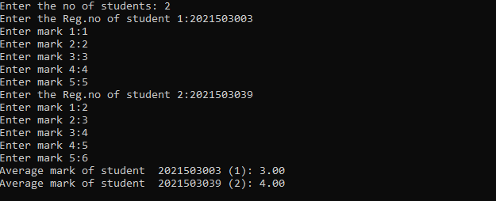

**RESULT:**

**Student record is created with Register Number , marks and Average is Calculated Successfully using Multi-dimensional Array.**

**SOURCE CODE:**

#include <stdio.h>

int main(){

double student[20][5];

int n, i, j;

printf("Enter No of Students:");

scanf("%d",&n);

for(i=0; i<n; i++){

printf("Enter Reg No: ");

scanf("%lf", &student[i][0]);

printf("Enter CGPA: ");

scanf("%lf", &student[i][1]);

printf("Enter Phone Number: ");

scanf("%lf", &student[i][2]);

}

printf(" Reg No\t\tPhone Number\tCGPA\n");

for(i=0; i<n; i++){

printf("%ld\t\t%ld\t%.2f\n",(long int)student[i][0], (long int)student[i][2],student[i][1]);

}

return 0;

}

**OUTPUT:**

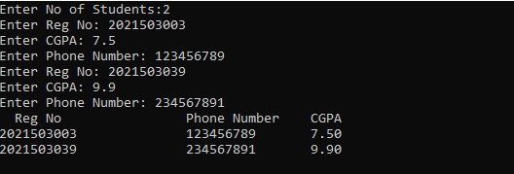

**RESULT:**

**Student record is created with Register Number , Phone , CGPA and displayed Successfully using Multi-dimensional Array.**